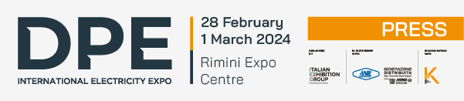

press release

IEG: THE NEW EDITION OF DPE – INTERNATIONAL ELECTRICITY EXPO IN 2024
SPACE UPGRADE FOR MAIN PLAYERS IN THE ELECTRICAL INDUSTRY

- From 28 February to 1 March at Rimini Expo Centre, in conjunction with KEY – The Energy Transition Expo
- Event dedicated to the latest in the electrical generation, transmission, distribution, security and automation ecosystem
- Organized by Italian Exhibition Group in collaboration with Generazione Distribuita – the Italian Association of Manufacturers and Distributors of Engines, Components and Generating Sets, member of ANIMA Confindustria – and Federazione ANIE

Rimini, 15 November 2023 – Returning to the Rimini Expo Centre for the second consecutive year, DPE, the event dedicated to the electrical generation, transmission, distribution, safety and automation ecosystem, is organized by Italian Exhibition Group in collaboration with Generazione Distribuita – manufacturers and distributors of engines, components and generating sets, member of ANIMA Confindustria - and, for the first time, Federazione ANIE.

The event will take place from 28 February to 1 March 2024 in pavilion A1 of the expo centre, in conjunction with KEY – The Energy Transition Expo, highlighting the close connection between generation, transformation, distribution and the transport of electricity and renewables.

Following the 2019 pilot edition and huge success in March 2023, DPE is now extending its vision, by further expanding the project, to involve, in line with the new "International Electricity Expo" payoff, all the big names in the electricity industry.

The current scenario, characterized by pivotal changes, is pushing for an urgent shift in energy transition. Diffused generation plays a crucial role in implementing this transformation, which cannot ignore the development of increasingly modern and efficient electrical infrastructures, which ensure greater flexibility and security in electrical energy supplies.

In this backdrop, DPE – International Electricity Expo presents itself as a comprehensive showcase of typical energy generation applications, featuring the vast range of cutting-edge solutions and technologies that are shaping the energy future in Europe and the Mediterranean basin. The latest innovations and products available on the market will be presented, to guarantee the stability and efficiency of the electricity grid and make it increasingly smart and digital: from small new generation power plants to generator sets, up to detailed electrical components or machinery, and energy efficiency.

DPE is geared toward designers, installers, distributors, utilities, consultancy and engineering companies, O&M, contractors, ESCOs, maintenance operators and rental companies, offering a far-reaching conference and training programme, that makes a deep dive into key issues related to energy: a unique opportunity to keep up to speed, discover new solutions, promote innovation and exchange ideas and knowledge, engaging with industry experts.

The event also aims to inspire and motivate the up-and-coming generation of energy professionals, offering students and young engineers the opportunity to enhance their skills and check out the latest trends and technologies.

“DPE has by now established itself as the benchmark event in the field of generation, transformation, distribution and transport of electricity for Europe and the countries bordering the Mediterranean, with a unique basket of solutions and content on the Italian trade fair scene" comments Corrado Peraboni, CEO of IEG. “For this reason, by virtue of the collaboration with strategic partners such as Generazione Distribuita and Federazione ANIE, we have decided to amplify the event, involving players from the entire electricity industry, as the new payoff announces. The next edition of DPE will be a stand-alone event, occupying an entire pavilion, but in parallel with KEY, to maximize all possible synergies and connections with the renewable energy sector".

“The Energy Transition is inconceivable without modern and efficient electrical infrastructures,” says Marco Monsurrò, president of Generazione Distribuita. “The entire concept of change, in fact, hinges around the widespread use of electricity as an electrical vector, both in industry and in the residential sector, as well as in mobility. This edition of DPE stems from the need to showcase the entire Italian and European electrical hardware industry, in the knowledge that the reshoring process of the supply chain, caused by the ongoing geopolitical dynamics, guarantees greater security for the entire power supply chain.”

“In recent years, the European energy system has entered a phase of radical transformation, focusing categorically on the green economy as a model of necessary and sustainable development. To implement this transformation - states Michele Lignola, General Director of Federazione ANIE - diffused generation plays a key role in strengthening electrical infrastructures which will have to be increasingly advanced and functional to guarantee new energy needs. DPE is an opportunity to present advanced technological solutions aimed at achieving the goals of the energy transition, under the pressure of growing environmental constraints. This is a complex process that requires the involvement of governments, industries, communities and individuals. It is a crucial response to the environmental and climate challenges of our time and represents a path towards a more sustainable and environmentally friendly future. Furthermore, DPE brings together for the first time the main players of the entire supply chain, becoming a reference event not only for our members but, in general, for the entire industry."

ABOUT DPE - International Electricity Expo
Event type: European Expo; Organizer: Italian Exhibition Group S.p.A.; Edition: 2nd; Dates: 28 February-1st March 2024; Website: www.dpeurope.it; LinkedIn: https://www.linkedin.com/company/dpe---distributed-power-europe/

ITALIAN EXHIBITION GROUP PRESS CONTACTS
head of media & corporate communication: Elisabetta Vitali; press office manager: Marco Forcellini; international press office manager: Silvia Giorgi; media@iegexpo.it

MEDIA AGENCY: Smartitaly Communications
Sara Scatena, s.scatena@smartitaly.it, mob. +39 338 7836985; Arianna Geli, a.geli@smartitaly.it, mob. +39 347 0917903

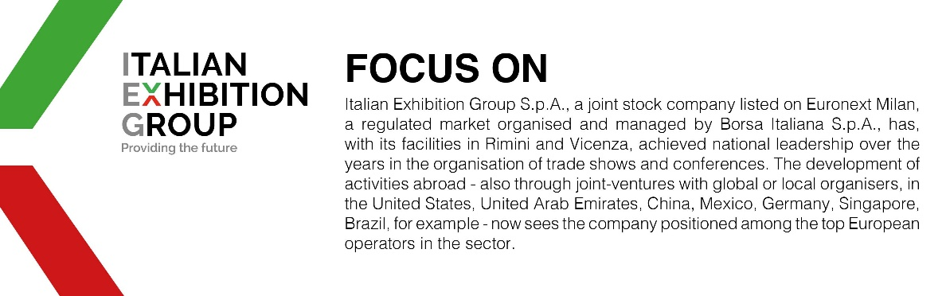

This press release contains forecast elements and estimates that reflect the management’s current opinions (“forward-looking statements”), particularly regarding future management performance, realization of investments, cash flow trends and the evolution of the financial structure. For their very nature, forward-looking statements have a component of risk and uncertainty, as they depend on the occurrence of future events. The effective results may differ (even significantly) from those announced, due to numerous factors, including, only by way of example: food service market and tourist flow trends in Italy, gold and jewellery market trends, green economy market trends; the evolution of raw material prices; general macroeconomic conditions; geopolitical factors and evolutions in the legislative framework. Moreover, the information contained in this release does not claim to be complete, and has not been verified by independent third parties. Forecasts, estimates and objectives contained herein are based on the information available to the Company as at the date of this release.

